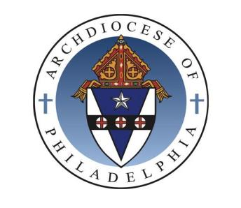
ARCHDIOCESE of PHILADELPHIA
Office for Divine Worship
222 North Seventeenth Street | Philadelphia, Pennsylvania 19103-1299
215-587-3696 www.ODWPhiladelphia.org www.CathedralPhilaConcerts.org

ARCHDIOCESAN WEDDING RITE WORKSHOP

Name Click here to enter text.

Parish Click here to enter text.

Parish City Click here to enter text. Parish Deanery Click here to enter text.

Phone day Click here to enter text. Cell Click here to enter text.

Email Click here to enter text.

YES, I will be attending

☐ Wednesday, May 3, 2017, 7:00-9:00 PM Cathedral Chapel

Cathedral Basilica of Saints Peter and Paul, Philadelphia, Pennsylvania 19103

.

Email to: cangelini@archphila.org Or

Mail to:

Archdiocesan Wedding Rite Workshop Registration
Office for Divine Worship
222 North 17th Street 7th Floor
Philadelphia PA 19103

